**KENDRIYA VIDYALAYA**

**RHE PUNE-20**



***PROJECT REPORT ON***

**SCHOOL MANAGEMENT SYSTEM**

SUBMITTED BY: **NIDHI KUMARI**

OF CLASS 12TH SCIENCE

ROLL NO: -

|  |
| --- |
| FOR THE PARTIAL FULFILMENTOF THE XII CBSE EXAMINATION  COMPUTER SCIENCE SESSION 2020-2021 |

UNDER THE GUIDANCE OF:

**MRS. SAVITA SHARMA [PGT COMPUTER SCIENCE]**

***CERTIFICATE***

*THIS IS TO CERTIFY THAT THE PROJECT TITLED “SCHOOL MANAGEMENT” IS SUCCESSFULLY DEVELOPED AND COMPLETED BY NIDHI KUMARI STUDENT OF CLASS XII SCIENCE UNDER THE GUIDANCE OF MRS. SAVITA SHARMA (PGT CS)*

*HE DEVELOPED THIS PROJECT IN THE SESSION 2019-2020 FOR THE PARTIAL FULFILMENT OF THE CENTRAL BOARD OF SECONDARY EXAMINATION 2020 AS THE PART OF PRACTICAL UNDER THE SUBJECT COMPUTER SCIENCE*

*______________ _____________*

*STUDENT INTERNAL EXAMINER*

*______________ _____________*

*EXTERNAL EXAMINER PRINCIPAL*

ACKNOWLEDGEMENT

**I would like to hereby thank everyone who helped me out in completing this project.**

**I am very thankful to our principal sir Mr. S.K.Kaiwart who has provided me all the equipments and arrangements which help me a lot to complete my project within the due time and for his help and encouragement throughout the year.**

**I am also thankful to our teacher Mrs.Savita Sharma (pgt Computer Science) for her guidance and constant encouragement that have been a source of inspiration to my entire project.**

**NIDHI KUMARI**

**XII SCIENCE**

**K.V.R.H.E KHADKI PUNE-20**

**INDEX**

1. **Overview of mysql and python**
2. **Need For the Project**
3. **Requirements**
4. **Database Design**
5. **Source code**
6. **Output**
7. **Bibliography**

**OVERVIEW OF MYSQL**

**What is database?**

A database is a collection of information related to a particular subject or purpose, such as tracking customer orders or maintaining a music collection. Using any RDBMS application software like MS SQL server,MySQL, Oracle, Sybase etc you can manage all your information from a single database file. Within the file, divide your data into separate storage containers called tables. you may retrieve the data using queries.

A table is collection of data about a specific topic, such as products or suppliers. Using a separate table for each topic means you can store that data only once, which makes your database more efficient and reduces data entry errors. Table organizes data into columns (called fields) and rows (called records).

A primary key is one or more fields whose values uniquely identify each record in one table from another table. A primary key is called foreign key when it is referred to from another table.

To find and retrieve just the data that meets conditions you specify, including data from multiple tables, create a query. A query can also update or delete multiple records at the same time, and performs built in or custom calculations on your data.

**Role of RDBMS Application Program:**

A computer works as an electronic filing system, which has large number of ways of cross referencing, and this allows the user many different ways in which to recognize and retrieve data. A database can handle business inventory, accounting and filing and use the information in its files to prepare summaries, estimates and other reports. The management of data in a database system is done by means of a general-purpose software package called a Database Management System (DBMS). Some commercially available DBMS are MS SQL Server, MS ACCESS, INGRES, ORACLE, and Sybase. A database management system, therefore, is a combination of hardware and software that can be used to set up and monitor a database, and can manage the updating and retrieval of database that has been stored in it. Most of the database management systems have the following capabilities:

* Creating of a table, addition, deletion, modification of records.
* Retrieving data collectively or selectively.
* The data stored can be sorted or indexed at the user's discretion and direction.
* Various reports can be produced from the system. These may be either standardized report or that may be specifically generated according to specific user definition.
* Mathematical functions can be performed and the data stored in the database can be manipulated with these functions to perform the desired calculations.
* To maintain data integrity and database use.

The DBMS interprets and processes users' requests to retrieve information from a database. In most cases, a query request will have to penetrate several layers of software in the DBMS and operating system before the physical database can be accessed. The DBMS responds to a query by invoking the appropriate subprograms, each of which performs its special function to interpret the query, or to locate the desired data in the database and present it in the desired order.

1.2What is My SQL?

The management of data in a database system is done by means of a general-purpose software package called a Database Management System (DBMS). Some commercially available RDBMS are MS SQL Server, MS ACCESS, INGRES, ORACLE, and Sybase.

MySQL, the most popular Open Source SQL database management system, is developed, distributed, and supported by Oracle Corporation. MySQL is named after co-founder Monty Widenius's daughter, My. The name of the MySQL Dolphin (our logo) is “Sakila,”.

* **MySQL is a database management system.**

A database is a structured collection of data. It may be anything from a simple shopping list to a picture gallery or the vast amounts of information in a corporate network. To add, access, and process data stored in a computer database, you need a database management system such as MySQL Server. Since computers are very good at handling large amounts of data, database management systems play a central role in computing, as standalone utilities, or as parts of other applications.

* **MySQL is based on SQL.**

A relational database stores data in separatetables rather than putting all the data in one big storeroom. This adds speed and flexibility. The SQL part of “MySQL” stands for “Structured Query Language.” SQL is the most common standardized language used to access databases and is defined by the ANSI/ISO SQL Standard. The SQL standard has been evolving since 1986 and several versions exist. In this manual, “SQL-92” refers to the standard released in 1992, “SQL:1999” refers to the standard released in 1999, and “SQL:2003” refers to the current version of the standard.

* **MySQL software is Open Source.**

Open Source means that it is possible for anyone to use and modify the software. Anybody can download the MySQL software from the Internet and use it without paying anything. If you wish, you may study the source code and change it to suit your needs. The MySQL software uses the GPL (GNU General Public License),

* **The MySQL Database Server is very fast, reliable, and easy to use.**

If that is what you are looking for, you should give it a try. MySQL Server also has a practical set of features developed in close cooperation with our users. You can find a performance comparison of MySQL Server with other database managers on our benchmark page. MySQL Server was originally developed to handle large databases much faster than existing solutions and has been successfully used in highly demanding production environments for several years. Although under constant development, MySQL Server today offers a rich and useful set of functions. Its connectivity, speed, and security make MySQL Server highly suited for accessing databases on the Internet.

* **MySQL Server works in client/server or embedded systems.**

The MySQL Database Software is a client/server system that consists of a multi-threaded SQL server that supports different backends, several different client programs and libraries, administrative tools, and a wide range of application programming interfaces (APIs).

**DESCRIPTION OF PROJECT:**

***For every school , its an important task for administration department is to manage student information details in a procedure oriented manner with latest updates for every year which need to be available for easy access.***

This can be provided by a simple students information system to help administration so as to efficiently manage student’s details

We have created this using Mysql database and python.

We are having user defined modules in our *project :-*

1.Admission ,2.student data ,3.marks ,4.result

In our main program, in which we have imported all the four modules. when we run the program main menu contents will be displayed with four options and asking to enter a number. If you give your choice as 1 then this admission module will run. It will again give you six choices 1.admission details, 2.show admission details, 3.search, 4.deletion of records ,5.update admission details and 6.return.Now if your choice is 1 i.e. admission details, then it will ask you for entering admission number then for entering roll no. then for entering name of student,then for entering address then it will ask phone no. and at last it will ask for class after that if you press enter botton , it will print “record has been saved in admission table”. This means a new record is added to the admission table. Now, if we have to check if our recor is actually added or not, so for this, we need to give our choice as 2 after we press enter the table which has been created in the database with new record added with the help of program will be displayed. Now if you give your choice as 3, it will ask for admission no. of the student whom we want to search, enter the admission no and then press enter the screen will display the record of that student. Now if we enter our choice as 4,it will ask for admission no, as we enter the admission no and press enter, the records of the student with that admission no. will be deleted and the screen will show “ Data deleted successfully”.

Now if we enter our choice as 5 i.e. update admission details, and press enter it will again ask you to enter your choice i.e. what you want to edit about student it will give you four options

1.edit name,2.edit address,3.edit phone number and 4.return…As per your reqirement you can update data from here. Now after that it will ask you for choice. If you enter 6, you will return to the main menu, Again it will ask you for your choice now if enter your choice as 2 i.e. student data, the student_data module will run and screen will be like this. It will again give you six options i.e.

1.add student records ,2.show student details ,3.search student record,4.delete student record, 5.edit student record and 6.Exit.

Now , if you enter your choice as 1, it will ask you for entering student’s information one by one and at last give output as “records has been saved in student table”. Now if you want to check that record which we have entered in student table or not, for this it will again ask you for entering your choice and youi need to enter 2 as your choice. Following will be displayed.

Now again it will ask you for entering your choice, if you want to delete any record, enter your choice as 4,it will again ask you for entering roll no. of the student whose record you want to delete, after you enter the roll no. and press enter, a message will be displayed i.e. data deleted successfully. Now it will again ask you for entering your choice,if you want to edit or update student details, then enter your choice as 5 and press enter. Again it will ask you for entering your choice i.e. whatever you want to edit, as per you requirement give input and edit the records.Again it will ask you for entering your choice, if you give your choice as 6, you will return to the main menu.

Again it will ask you for entering your choice if you enter your choice as 3 marks module will run. It will again ask you for entering your choice , if you want to see marks of all the students, enter your choice as 1,and press enter ,markr of all the students will be displayed on the screen. As done before you can enter other choices and search ,delete or update marks in marks table. Now if you enter your choice as 5, you will return to the main menu .Again it will ask you for entering your choice if you enter your choice as 4 , result module will run ask for entering number for displaying relults of particular test. Again it will ask you for entering your choice, if you give your choice as 5 , you will exit the program and a message will get printed “Process finished with exit code 0”.

**NEED OF PROJECT**

Our world is quickly becoming the digital one where time consuming and complicated activities and routines are simplified by using new technologies and derivatives . The avent of thi new technology is what we call our SCOOL MANAGEMENT SYSTEM.

In the offline system, it is an overhead to keep the records related to faculty, student, parents and other school staffs on the papers.

Everything related to their progress in the system is marked manually. E.g. A report of a student’s attendance is generated monthly is shown to his / her parents.

Now, a regular student, going to the school every day, is marked absent for a day by mistake. It is a burden to take out the register and view the records.

As you can see, it is a very time-consuming process and it costs much.

Its other aim is to minimize the paperwork as minimum as we can so that there is no need to cut more and more trees. Indirectly, we will be helping the Mother Nature

Another benefit of our project is that data is safe as we are using mysql database which is paasword protected and we can store unlimited data about students of the school and access it easily.

As we know time is most precious thing nowadays, it saves a lot of time.

**HARDWARE USED:**

* While developing the system, the used hardware are:-

PC with i5 processor or sometimes, processor having 4GB RAM, and other required devices.

**SOFTWARE *USED:***

Microsoft Windows® 10 as Operating System.

1. Python’s pycharm as Front end Development environment
2. MySQL as Back-end for Testing.

**DOCUMENTATION:**

MS-Word 2010 for documentation.

**DATABASE DESIGN:**

We have created three tables using mysql database.

Table 1: **Admission table**

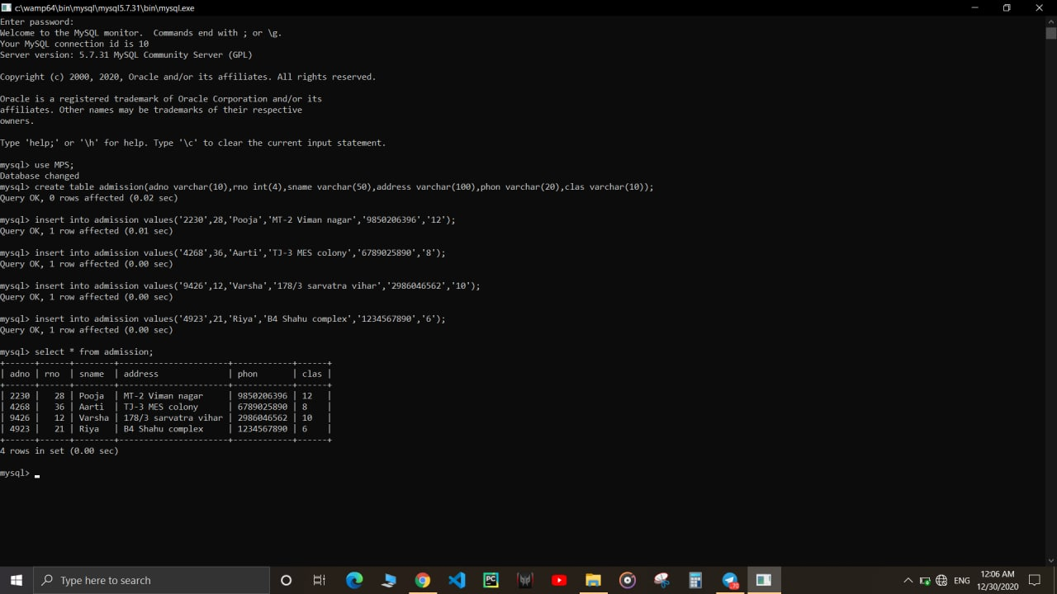

Table 2:**student table**

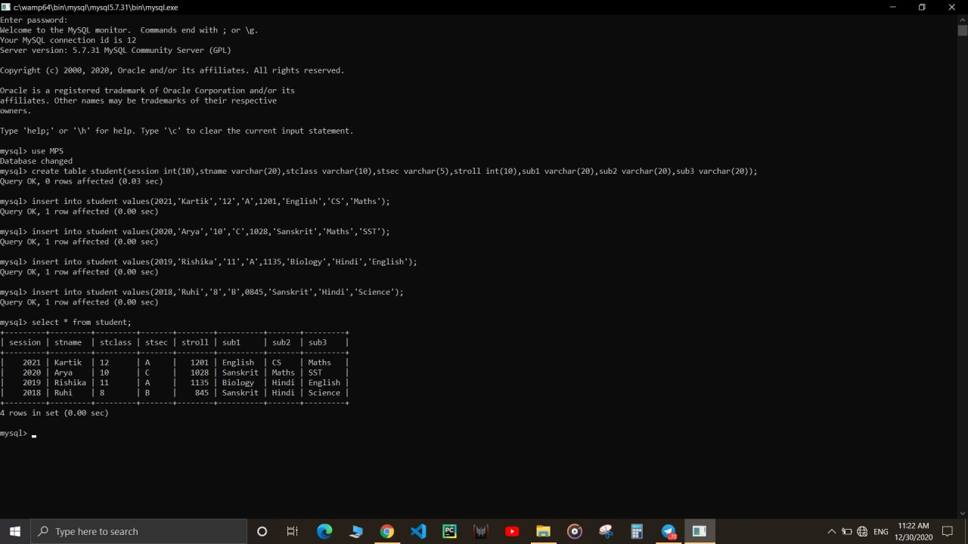

Table 3: **marks table**

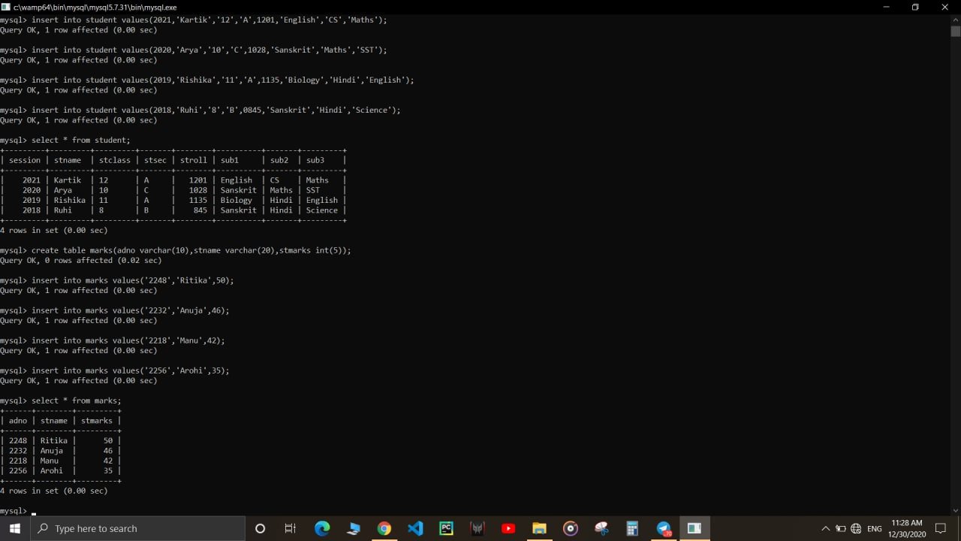

**Table 4**: **Result table**

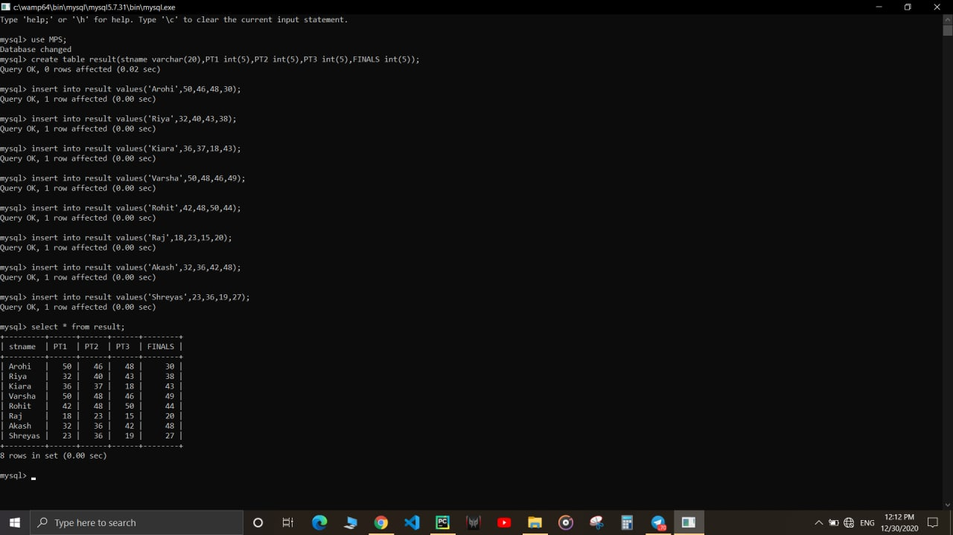

**Functions used:**

**1.ADM_MENU():**

**This function is used to call admission module of program.**

**2.STU_MENU()**

**This function is used to call STU_MENU() function from student_data module.**

**3.MARKS_MENU()**

**This function is used to call marks marks menu function from marks module.**

**4.RESULT_MENU()**

**This function is used to call marks result menu function from marks module.**

**5.admission.admin_details()**

**To call admin details function from admission module to display all details of admission table.**

**6.admission.show_Admin_details()**

**To call show admin details function from admission module and to display all details of admission table.**

1. **admission.search_Admin_details()**

**To call search admin details function from admission module and to search for particular records of admission table.**

**9.result.delete_result()**

**To call delete result function from result module and to delete a particular function from result table.**

**10. result.edit_result()**

**To call edit result function from result module and to edit any column of any record from result table.**

**i)result.edit_PT1() : it is used to edit PT1 marks**

**ii)result.edit_PT2() : it is used to edit PT2 marks**

**iii)result.edit_PT3() : it is used to edit PT3 marks**

**iv)result.edit_PT4() : it is used to edit PT4 marks**

**v)result.edit_FINALS() : it is used to edit finals marks.**

**11.student_data.search_stu_details()**

**It is used to seach a particular record of student table.**

**12.student_data.delete_stu_details()**

**It is used to delete a particular record of student table.**

**13.student_data.edit_stu_details()**

**It is used to update a particular record of student table.**

**14.marks.show_marks()**

**To call show marks functions from marks module to display all records from marks table.**

**15.marks.search_marks()**

**To call search marks functions from marks module to search for any particular record from marks table.**

**16. marks.delete_marks()**

**To call delete marks functions from marks module to delete any particular record from marks table.**

**17. Marks.edit_marks ()**

**To call show marks functions from marks module to edit any particular record from marks table.**

**Source code:**

*We are having user defined modules in our project , so these are:-

**1. admission:-**

The source code of admission module is:-

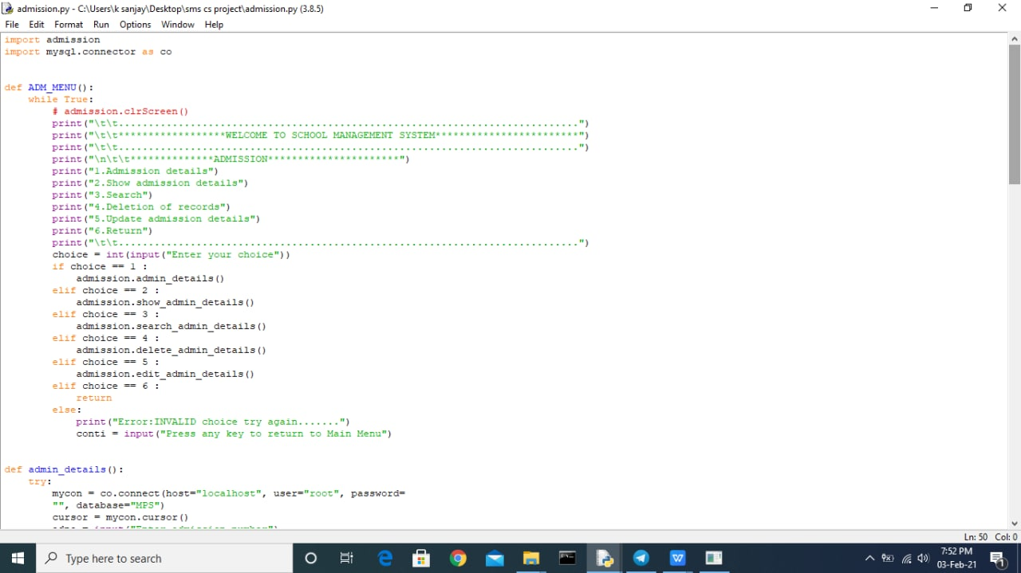

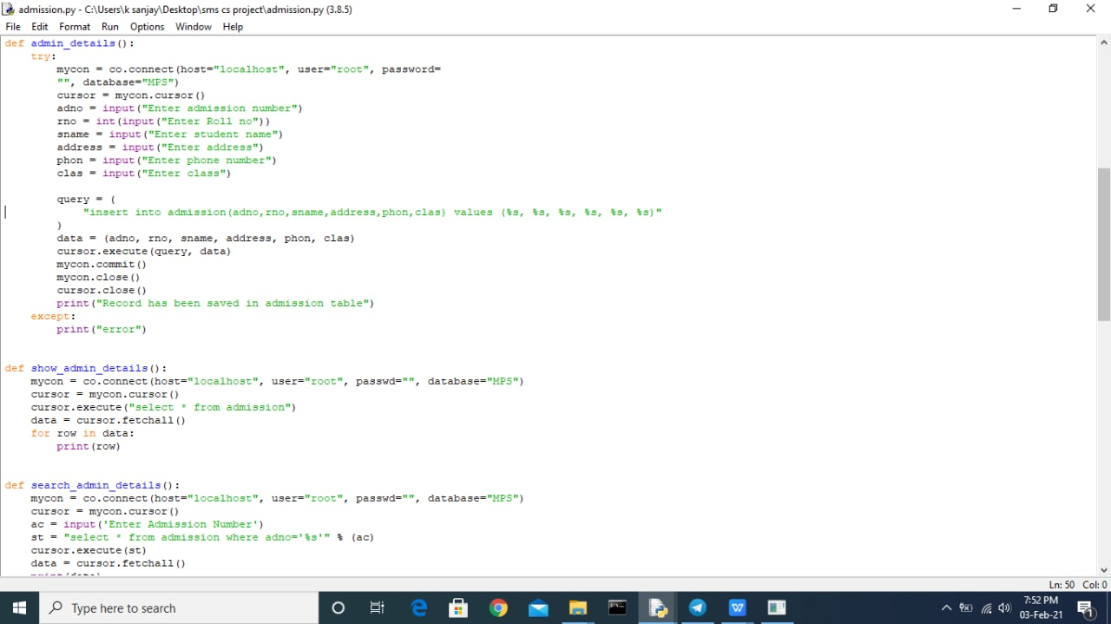

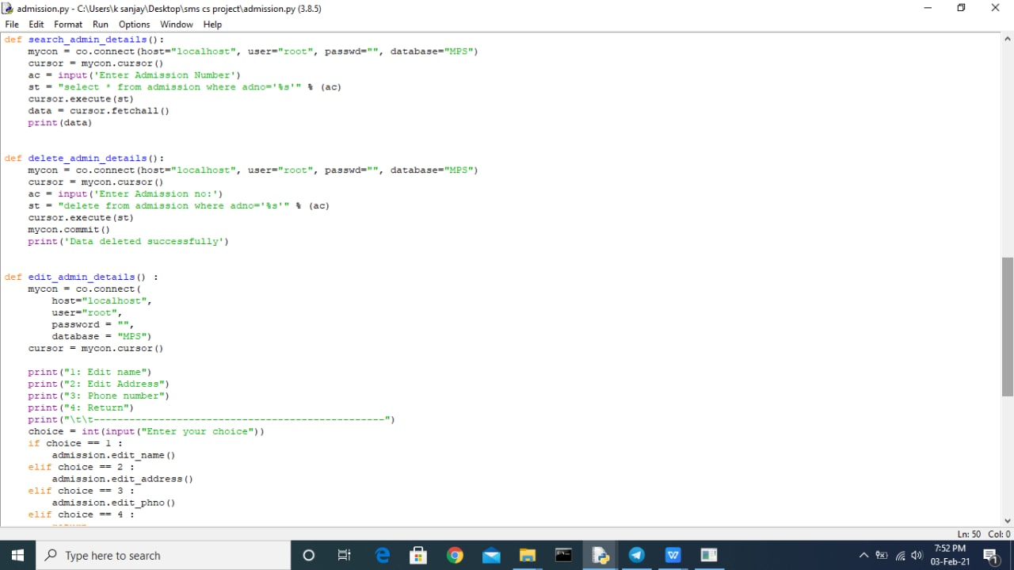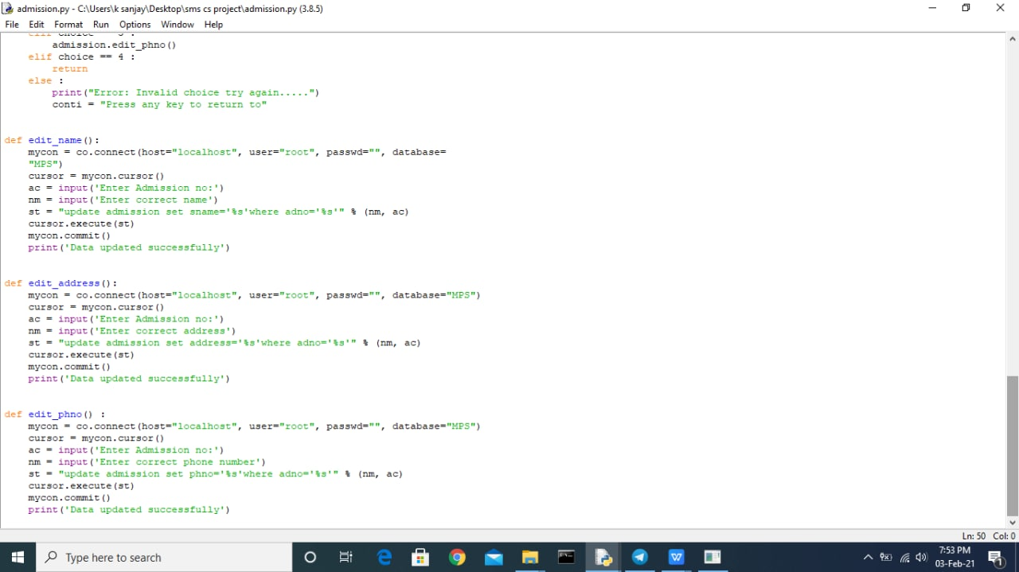





**2.Student data module:-**

The source code of student data module is:-

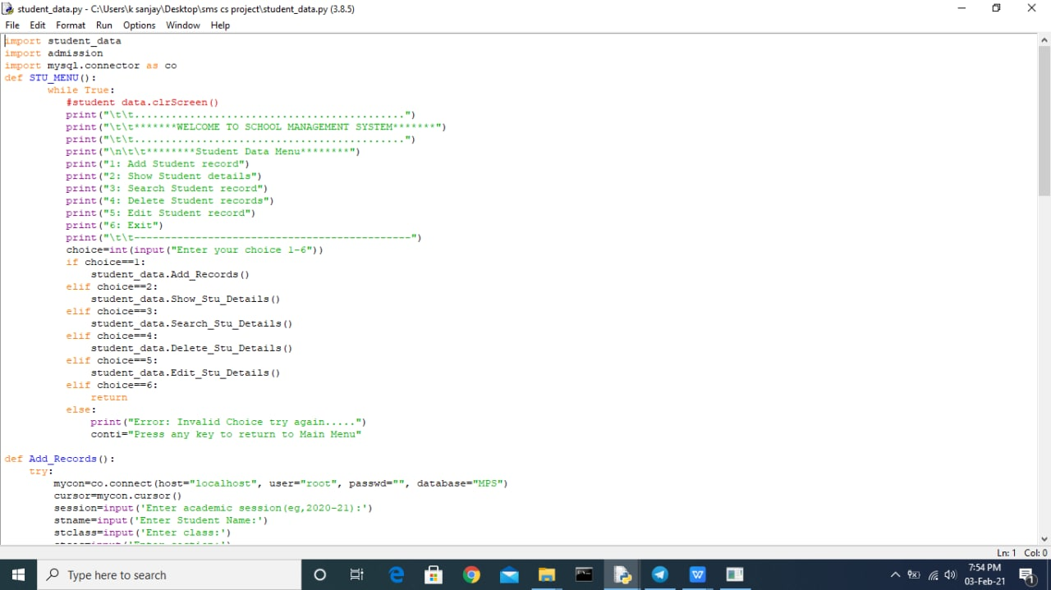



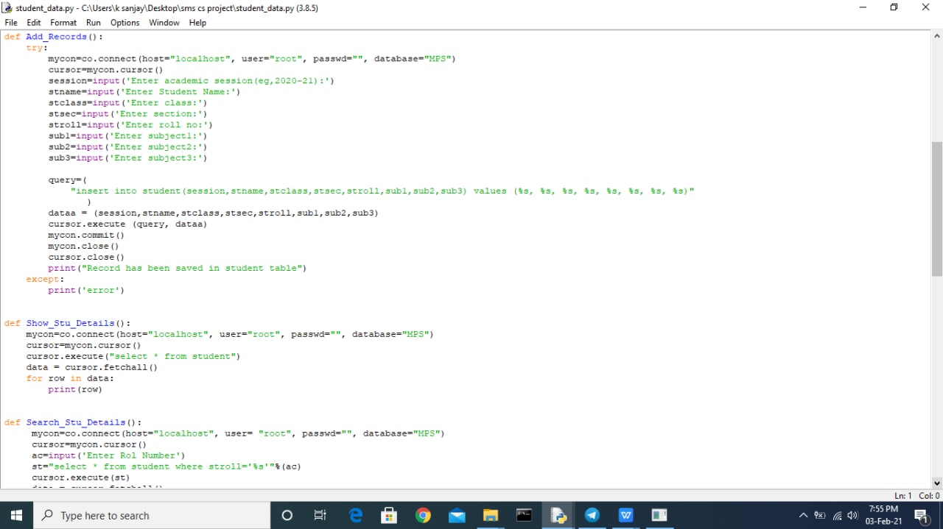

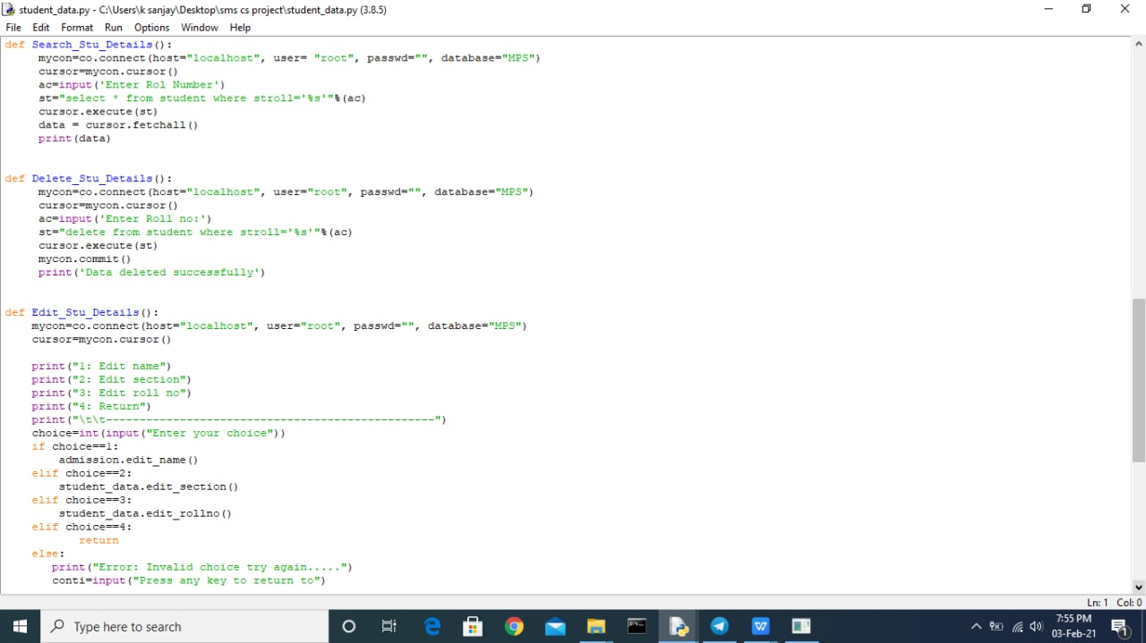

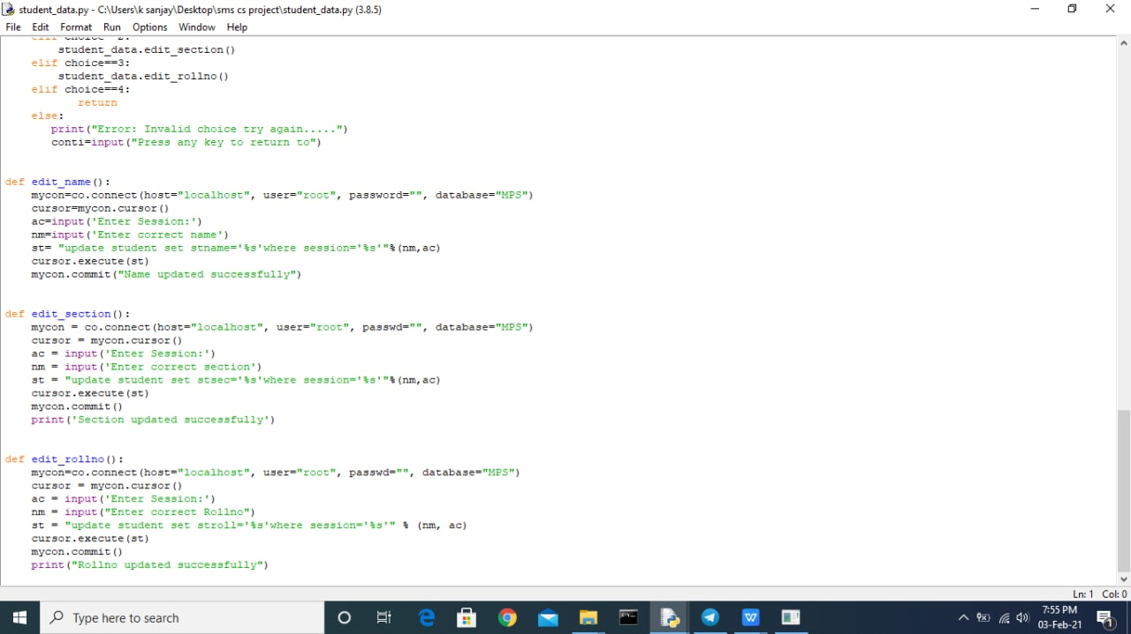

**3.marks module:-**

The source code of marks module is:-

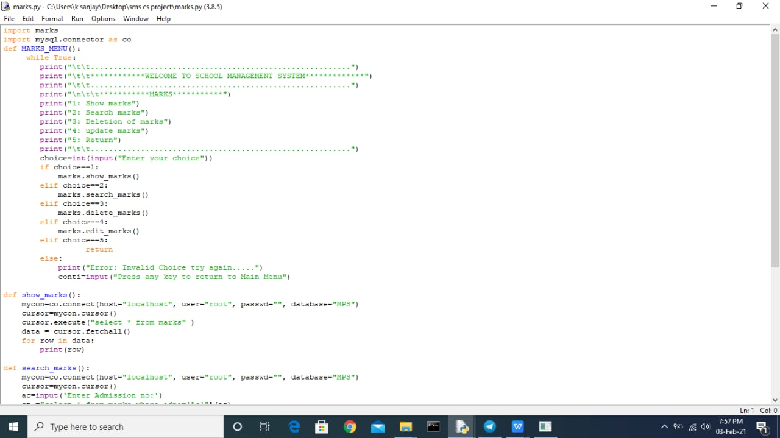

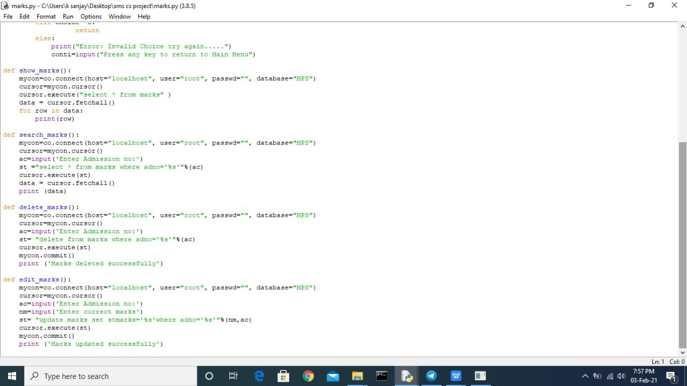

**4.result module:-**

**The source code of result module is**

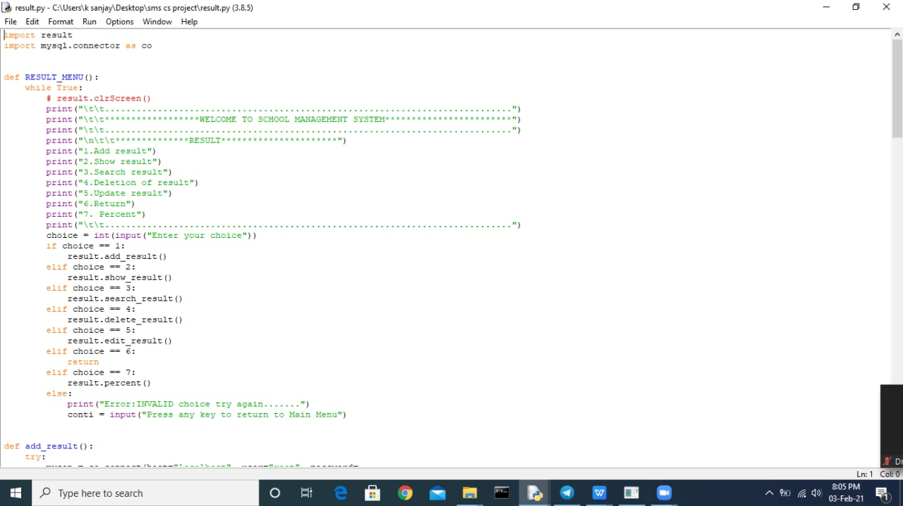

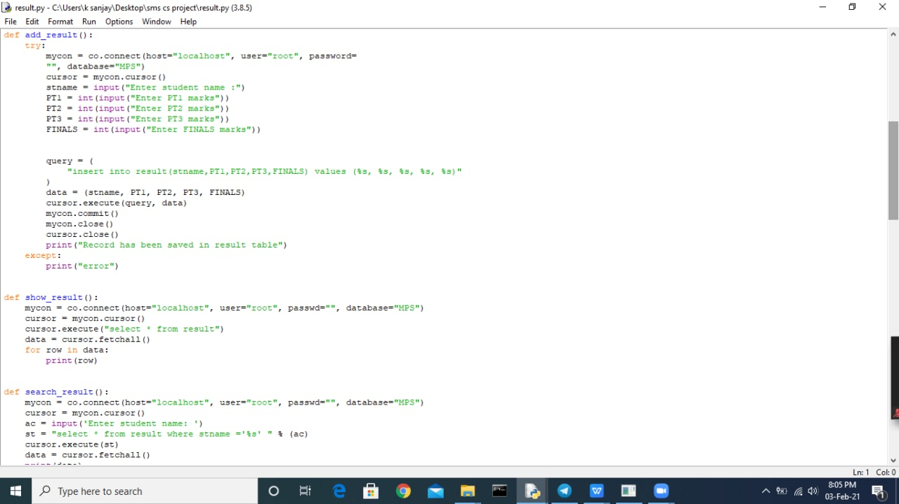

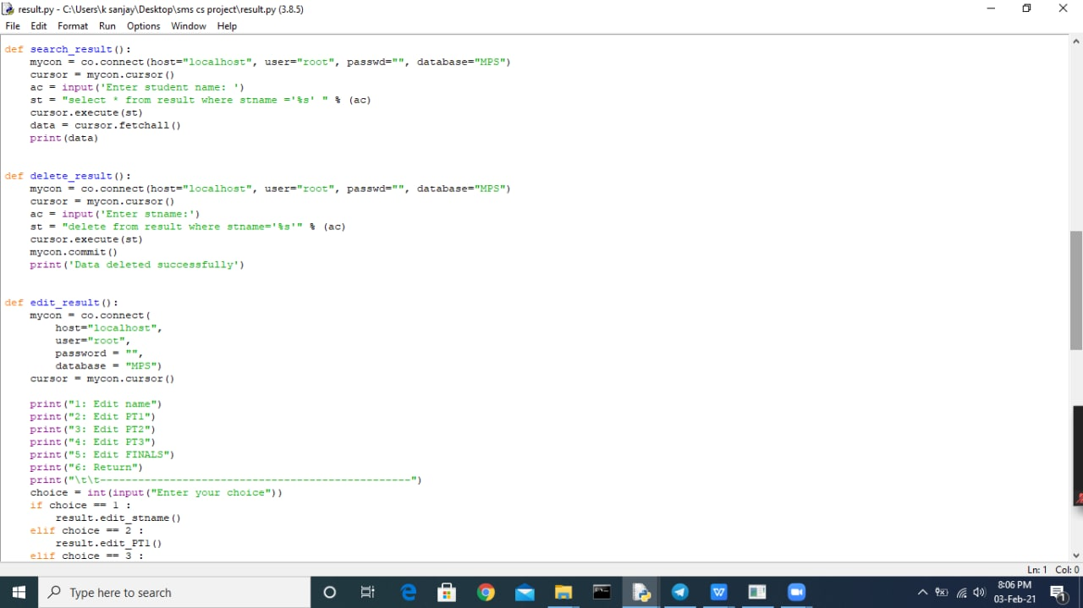



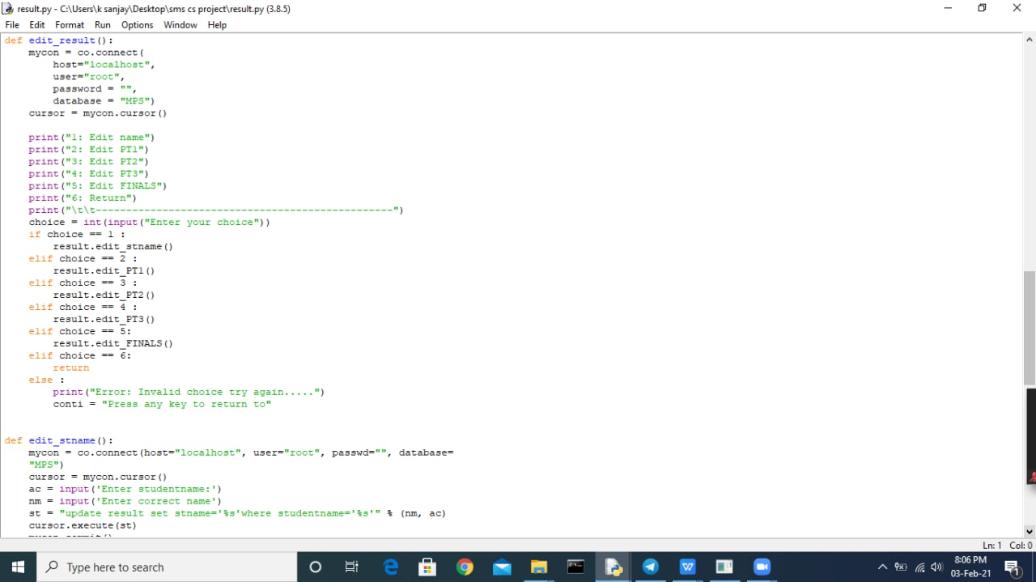

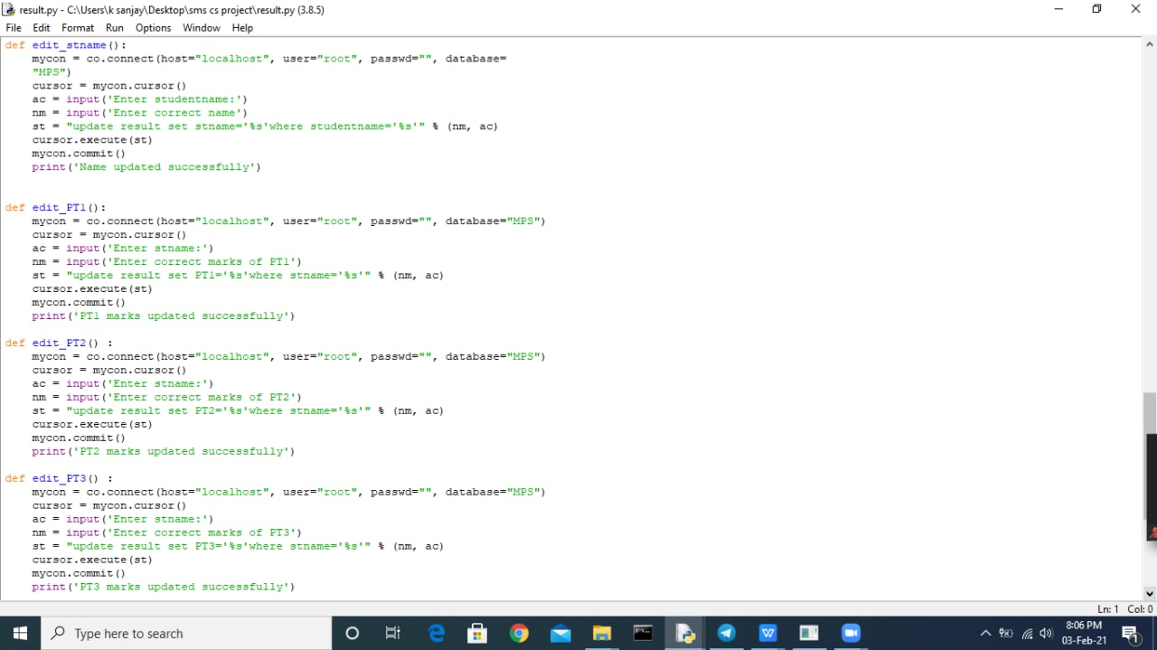

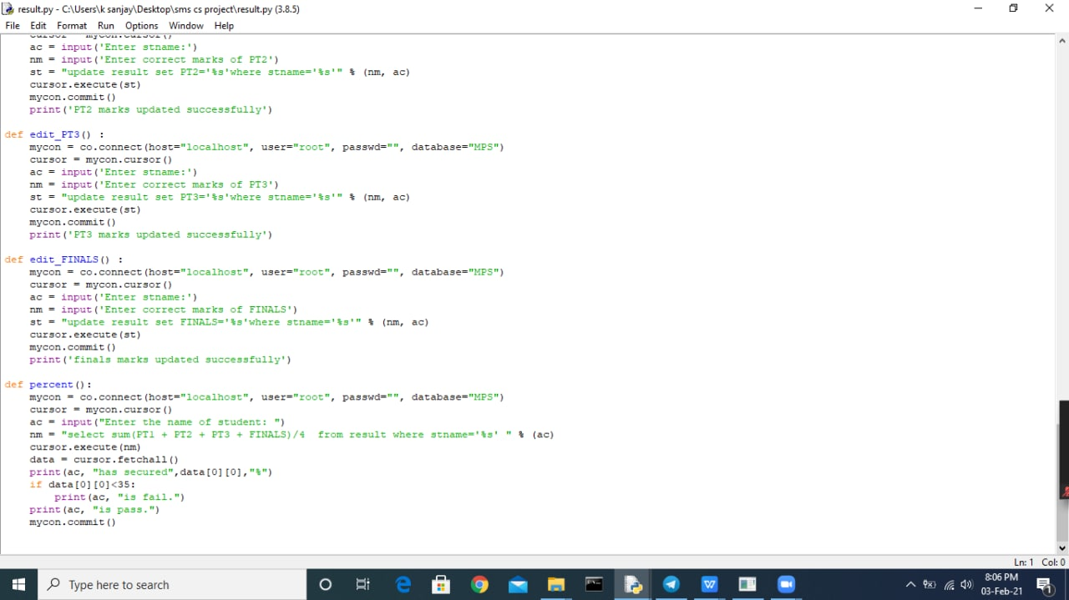

5**.main menu module**:-

The source code of main menu module is:-

Now ,this is our main program, in which we have used all the four modules in it.

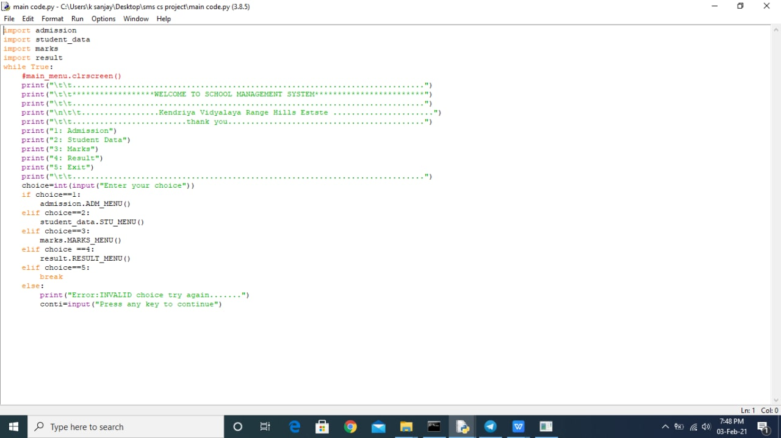

**OUTPUT**

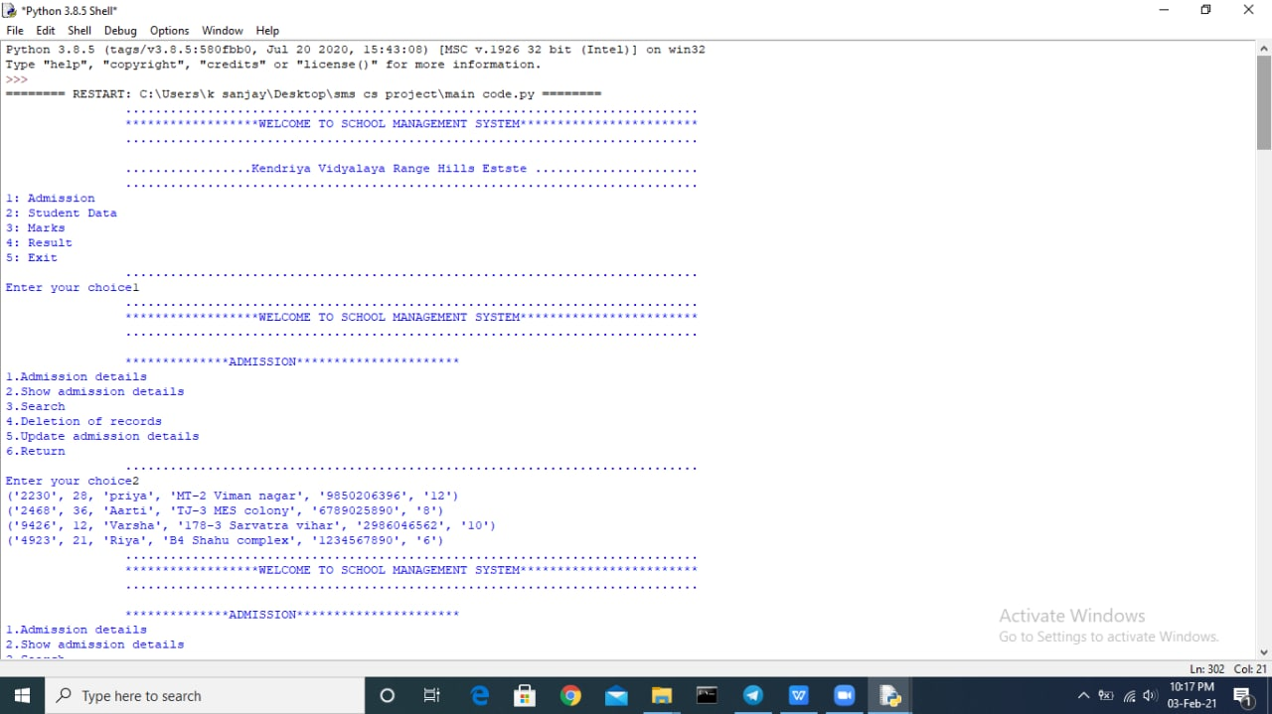

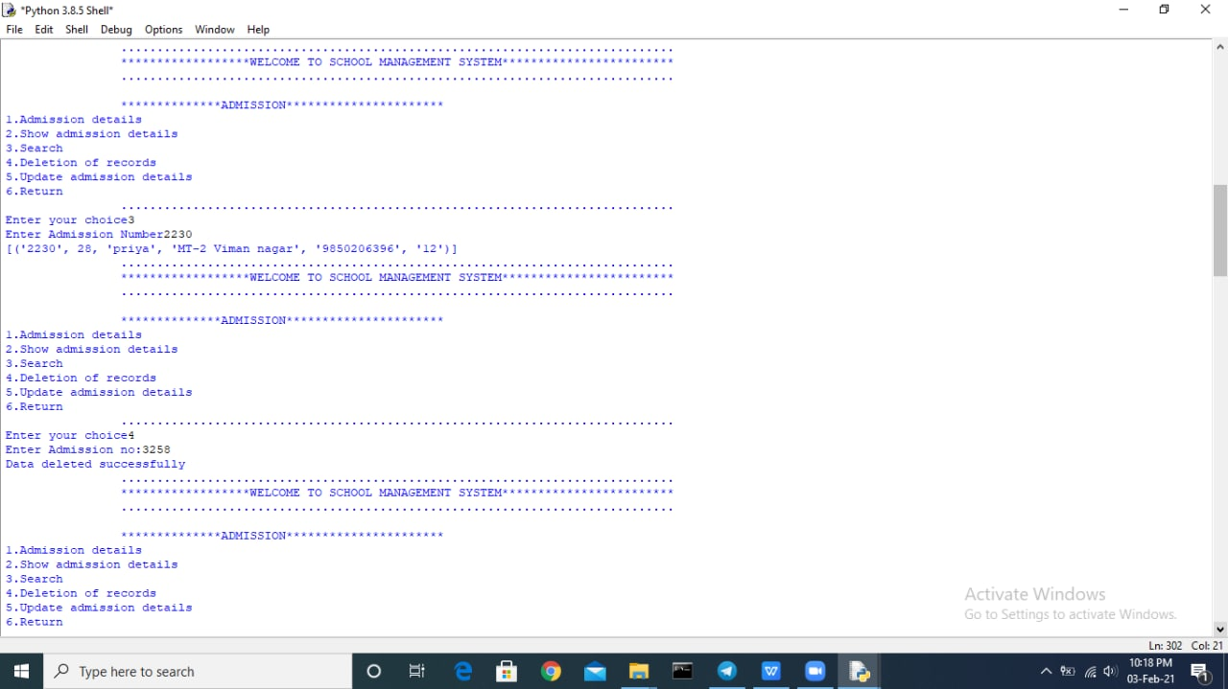



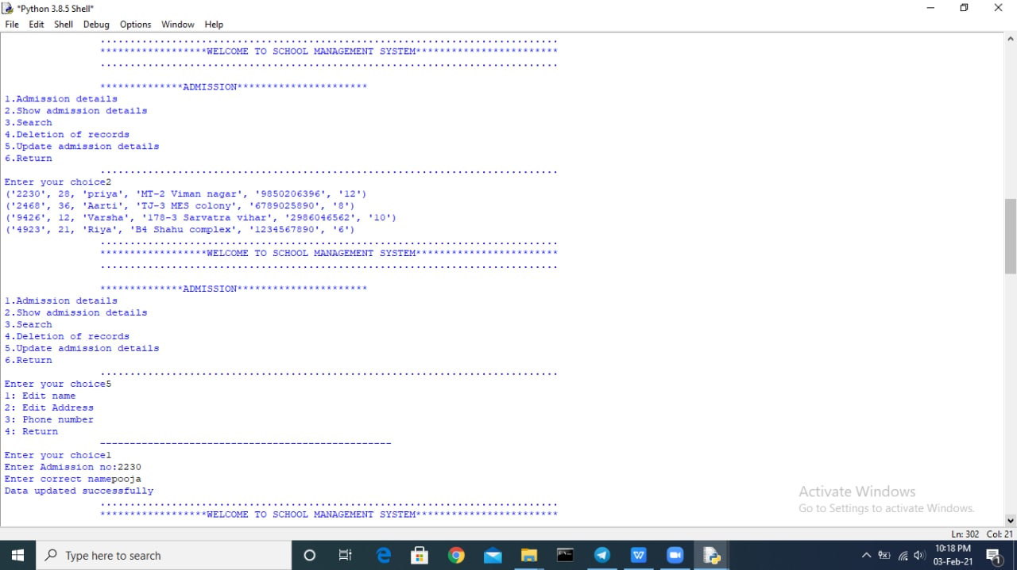

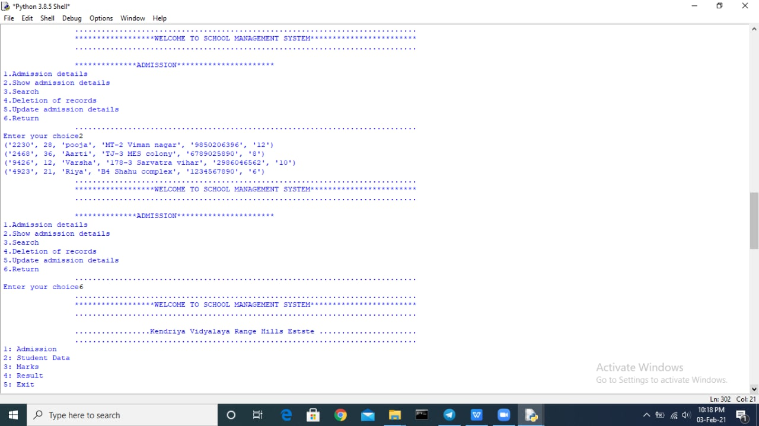

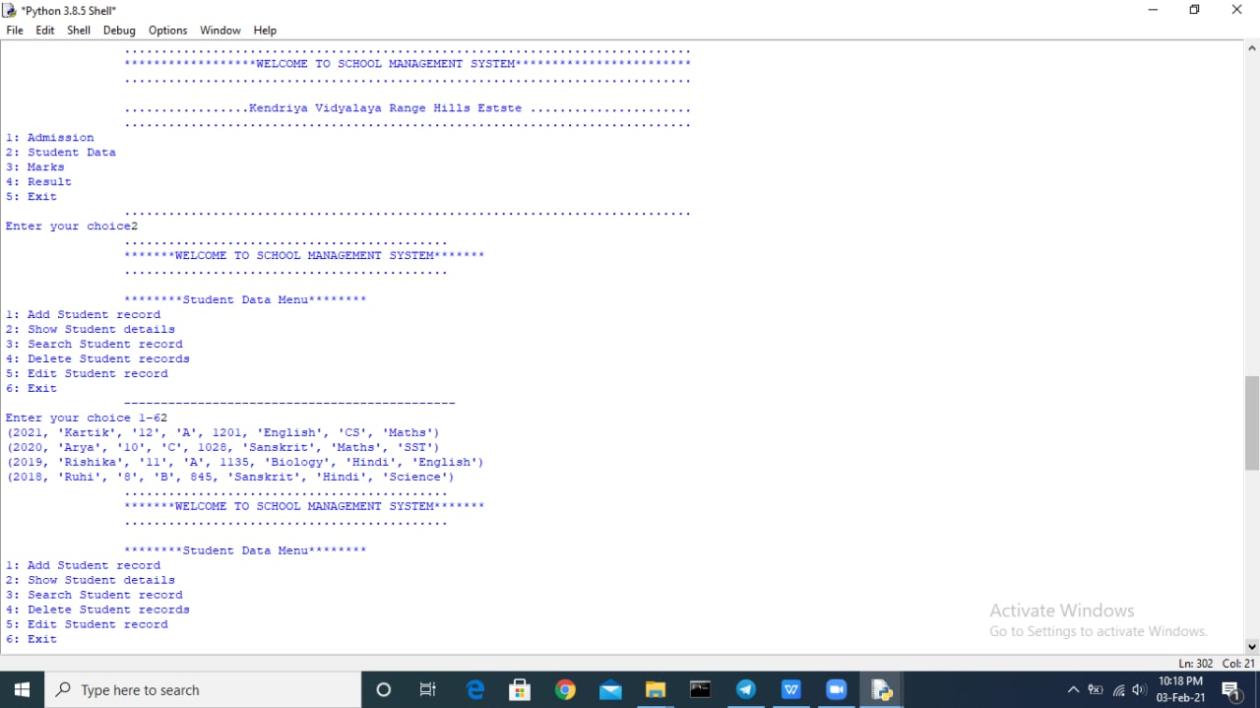

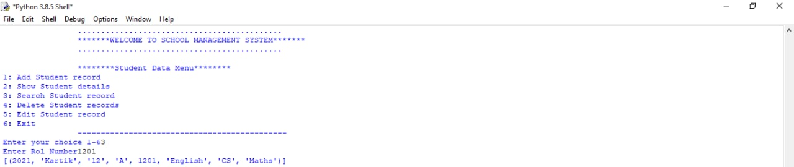

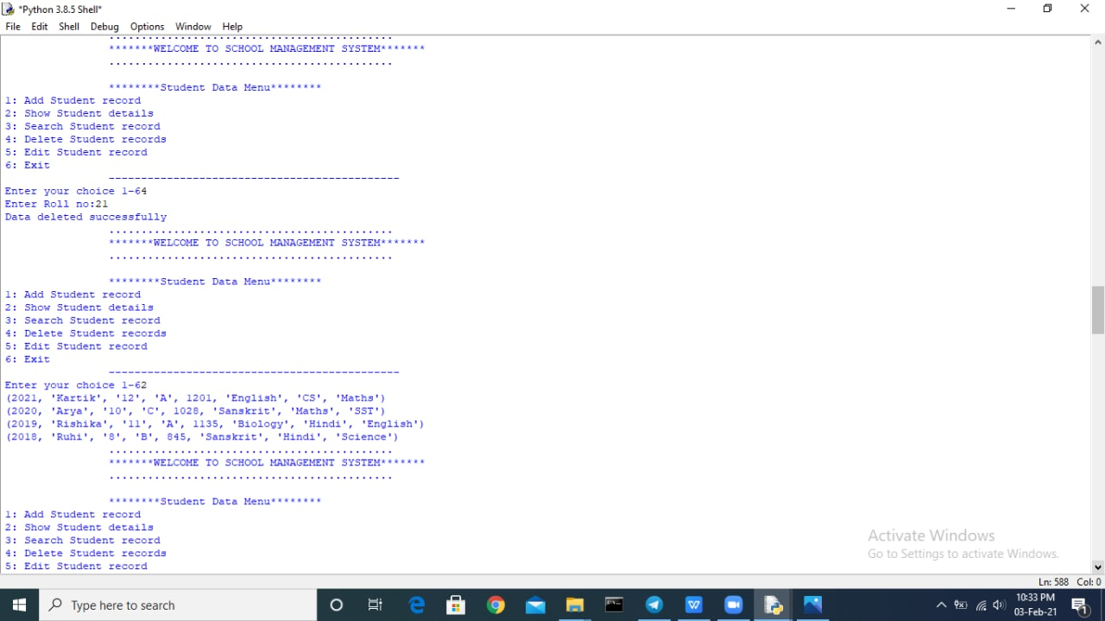

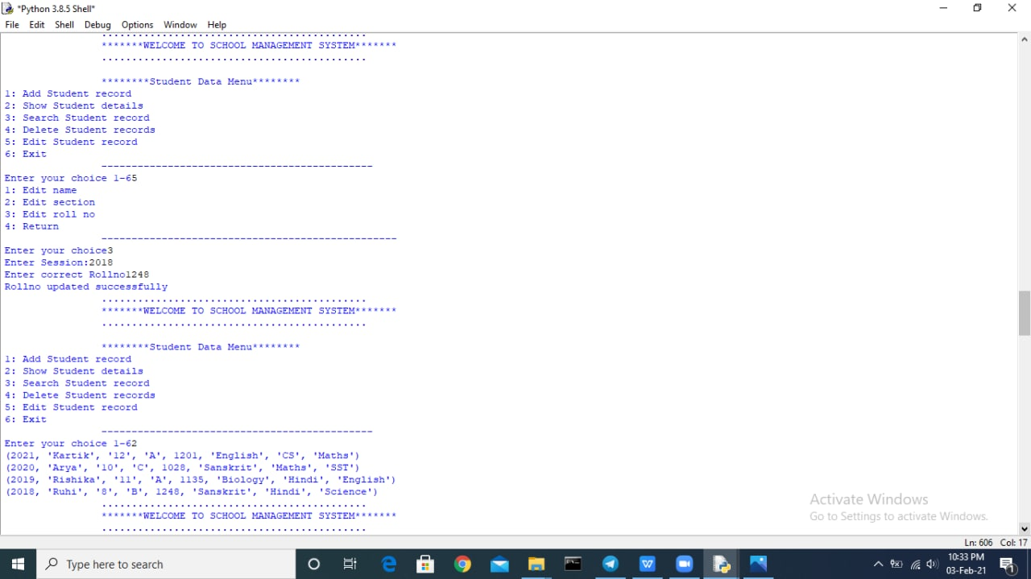

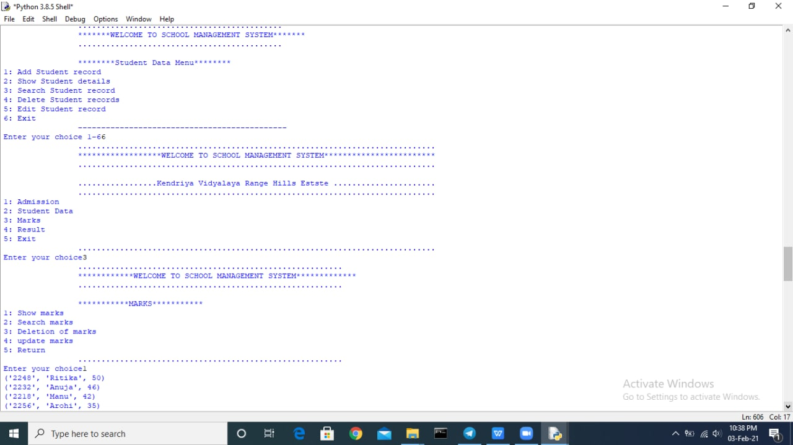



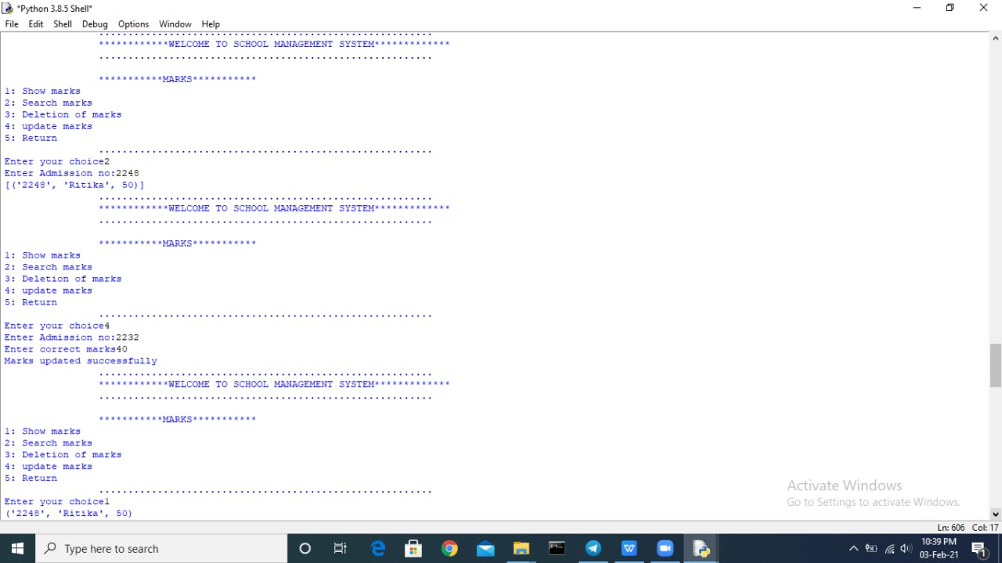



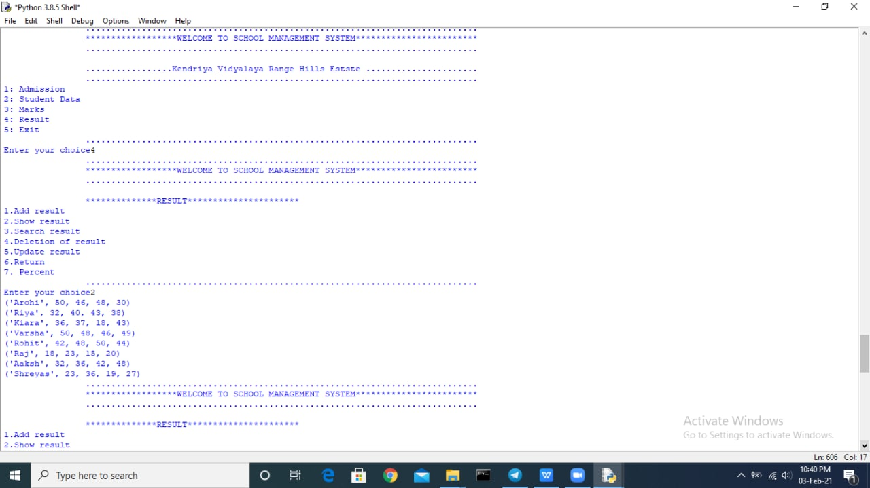

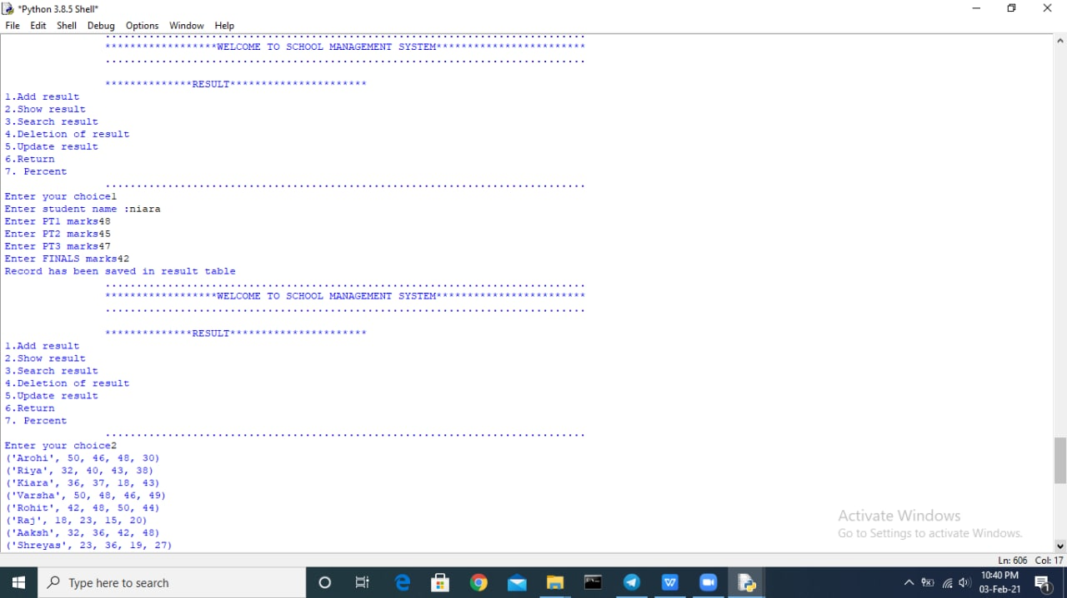

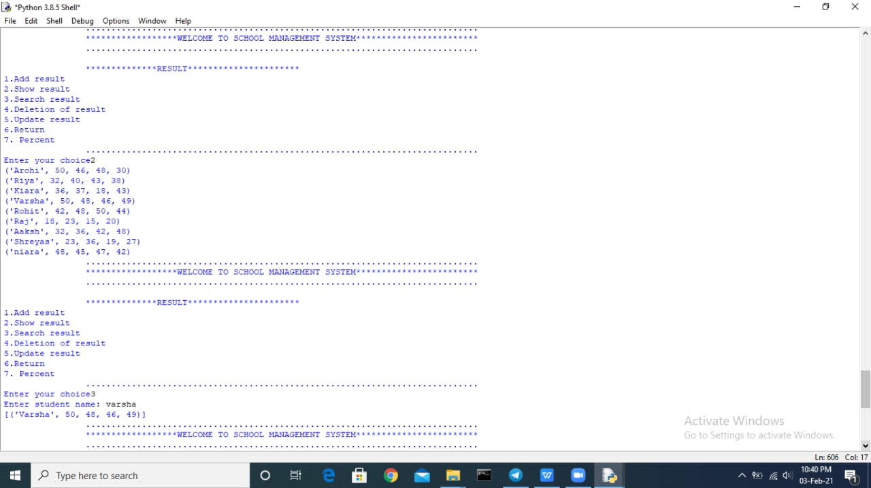

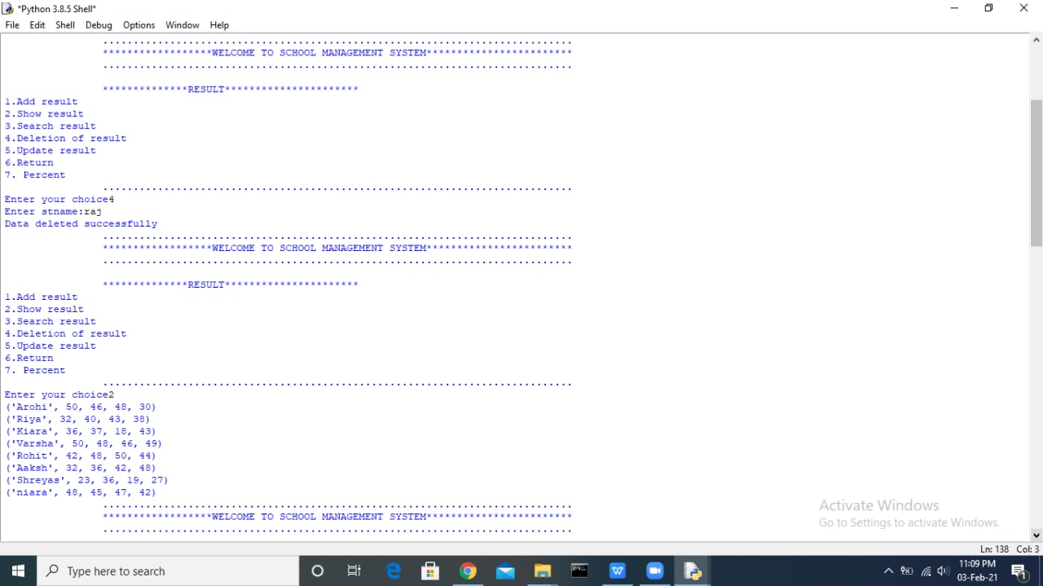

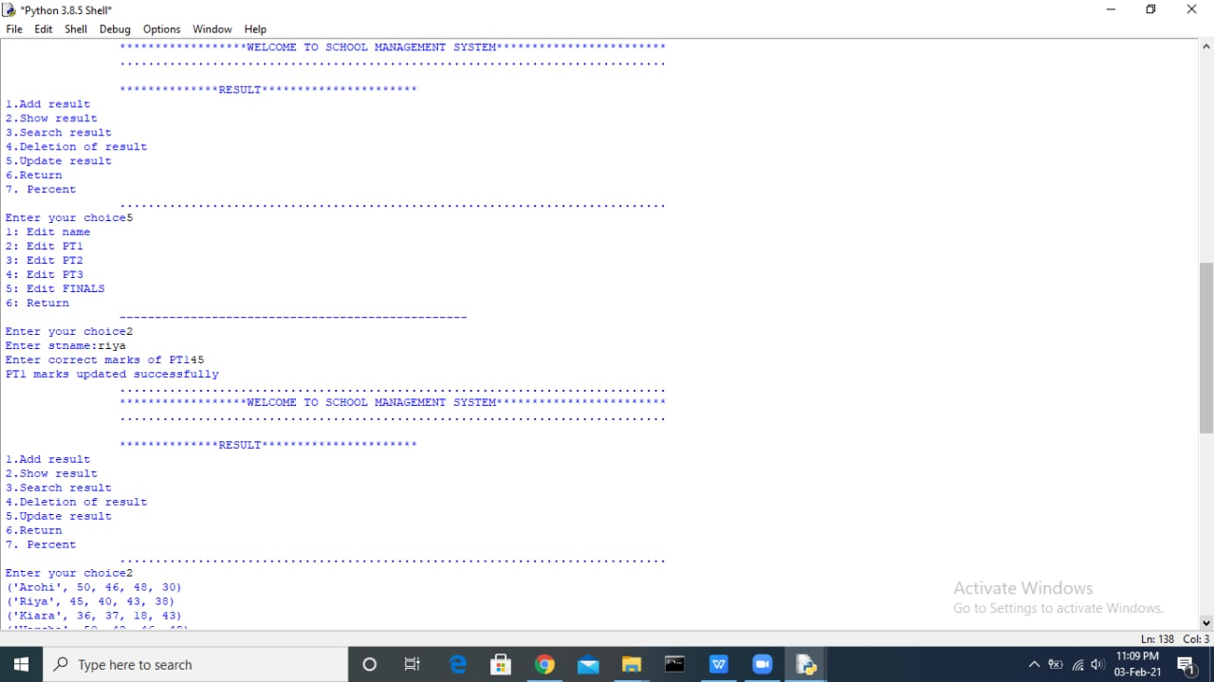

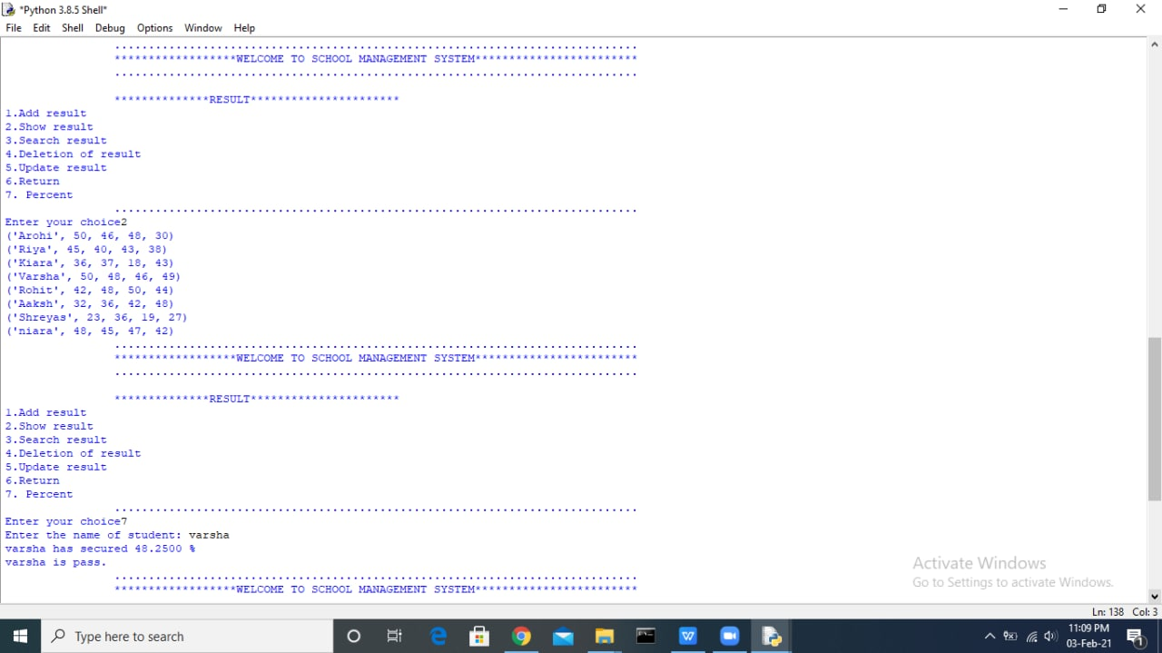

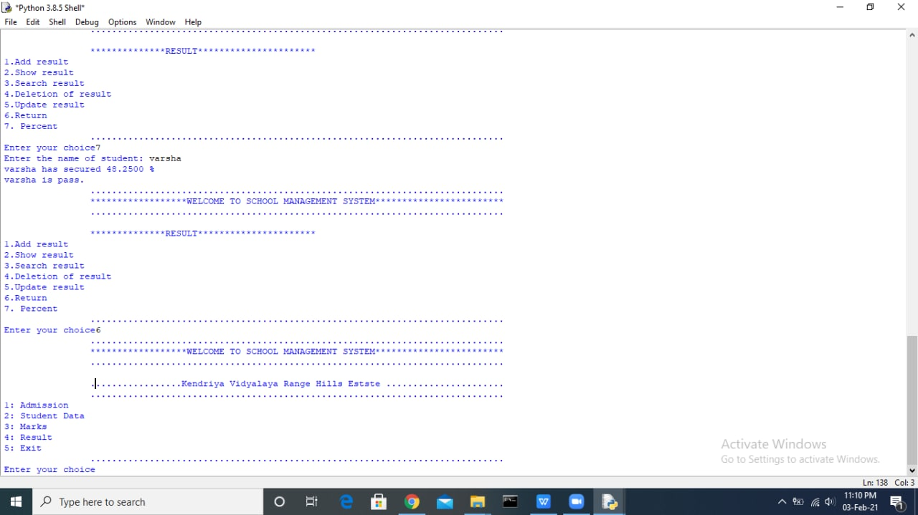

**BIBILOGRAPHY**

Python: Sumita Arora

www.Wikipedia.com

**....THANKYOU….**